}

1. **PARTE I**

| **1. Antecedentes Personales** |
| --- |
| A continuación, se presenta una tabla en la que debes completar la información solicitada. |

| Nombre estudiante | **Lucas Acevedo, Benjamin Rocco, Alvaro Rios** |
| --- | --- |
| Rut | **21.060.885-0** |
| Carrera | **Ingenieria en Informatica** |
| Sede | **Antonio Varas** |

| **2. Descripción Proyecto APT** |
| --- |
| En la descripción debes señalar brevemente el nombre de tu proyecto APT y las competencias del perfil de egreso que vas a poner en práctica. Si en tu carrera están definidas las áreas de desempeño, también menciona a qué áreas de desempeño está vinculado el proyecto. |

| Nombre del proyecto | **SeguRed** |
| --- | --- |
| Área (s) de desempeño(s) | **Área de las tecnologías de información** |
| Competencias | * **Gestión de Proyectos**: Planificación e implementación de un sistema tecnológico en un entorno real. * **Seguridad Informática**: Protección de los datos capturados a través de medidas de seguridad como el cifrado. * **Desarrollo de Soluciones Tecnológicas**: Diseño e integración de software de reconocimiento facial con la infraestructura existente en el sistema de transporte público. |

| **3. Fundamentación Proyecto APT** |
| --- |
| A continuación, se presentan distintos campos que debes completar con la información solicitada. Esta sección busca que describas en detalle tu proyecto y justifiques su relevancia y pertinencia. |

| Relevancia del proyecto APT | *Todo proyecto, ya sea una innovación, producto, servicio, etc., pretende dar respuesta a una situación o problemática. Señala qué problema busca solucionar tu proyecto y la relevancia que tiene para el campo laboral de tu carrera. También menciona el contexto en que esta problemática se sitúa (lugar, a quienes impactaría, etc.). Es importante que esta problemática sea relevante en el contexto de la profesión, siendo su resolución un aporte real o simulado a la organización u entorno en el que se sitúa. Algunas preguntas que pueden ayudarte a responder este apartado son:*   * *¿Por qué escogiste este tema? ¿Por qué es relevante este tema para el campo laboral de tu carrera?* We chose this topic because we found the subject of deep learning fascinating, and we also noticed a recurring issue in public transportation: fare evasion. This project is particularly relevant to our field of study as it serves as a clear example of machine learning applied in real-world situations. * *¿Dónde se ubica la situación que vas a abordar?* In Santiago, Chile * *¿A quiénes afecta o impacta la situación que vas a abordar?* citizens who use the RED bus system * *¿Cuál sería el aporte de valor (real o simulado) de tu Proyecto APT para el contexto laboral y/o social en que se situaría?* Public Safety and Compliance |
| --- | --- |
| Descripción del Proyecto APT | In recent years, due to the COVID-19 pandemic and the social unrest of 2019, fare evasion on RED buses has been on the rise. Evasion rates increased from 28.5% in 2018 (National Inspection Program, 2018) to 38.2% in the first half of 2024 (Metropolitan Public Transport Directory, 2024).  The facial recognition project on RED buses aims to identify individuals who evade fare payment to improve the safety and efficiency of Chile's public transportation system. Based on Law 19.628 on the Protection of Privacy, it ensures that data handling is carried out legally, securely, and transparently. The technology used will not impose penalties but will seek to deter fare evasion through facial identification. |
| Pertinencia del proyecto con el perfil de egreso | This project aligns with my professional interests in the field of cybersecurity, the development of intelligent systems, and the application of advanced technologies to solve urban challenges. By working on this project, I am gaining experience in the implementation of facial recognition technologies and the management of large datasets, which are essential skills for my professional growth. |
| Relación con los intereses profesionales | This project aligns with my professional interests in the field of cybersecurity, the development of intelligent systems, and the application of advanced technologies to address urban issues. By working on this project, I am gaining experience in implementing facial recognition technologies and managing large datasets, which are essential skills for my professional development. |
| Factibilidad de desarrollo del Proyecto APT | *Justifica brevemente por qué es posible desarrollar tu proyecto APT. Considera el tiempo y materiales que necesitas para desarrollarlo, así como los posibles factores externos que podrían dificultar y facilitar su desarrollo.*  *¿Por qué crees es posible desarrollar tu Proyecto APT?*  We believe it is possible to complete this APT project within the semester by utilizing effective planning and commitment. Additionally, the allocated hours and the lighter course load will help us stay focused, along with the resources provided by the institution. |

1. **PARTE II**

| **4. Objetivos** |
| --- |
| En este apartado debes definir objetivos generales y específicos del Proyecto APT. Es importante aclarar que los objetivos se deben plantear en forma clara, concisa y sin dar mayores explicaciones, es decir, deben entenderse por sí solos. Se sugiere redactarlos utilizando un verbo en infinitivo, pues ello obliga a precisar acciones concretas. |

| Objetivo general | The facial recognition project on RED buses aims to identify individuals who evade fare payments to improve the safety and efficiency of Chile's public transportation system. Based on Law 19.628 on the Protection of Privacy, the handling of data is ensured to be legal, secure, and transparent. The technology employed will not impose penalties but will instead seek to deter fare evasion through facial identification. |
| --- | --- |
| Objetivos específicos | The goal of this project is to develop a system capable of detecting faces in images using deep learning models. Unlike real-time facial recognition systems, this project focuses on processing images sequentially, allowing for face detection in photos or previously captured images. The system will analyze each image to identify and delineate the faces present, providing a robust solution for subsequent tasks such as authentication, emotion analysis, or classification. |

| **5. Metodología** |
| --- |
| En el siguiente apartado deberás describir la metodología, propia de tu disciplina, que utilizarás para resolver el proyecto APT antes descrito, incluyendo las etapas y métodos de trabajo. |

| Descripción de la Metodología |
| --- |
| The project will follow the waterfall methodology, which involves completing each phase of the project before moving on to the next. The structure of the work is organized as follows:   1. **Planning:** In this initial phase, the foundation of the project will be established, including the creation of the Project Charter, Work Breakdown Structure (WBS), Gantt Chart, and RACI Matrix to assign responsibilities. A Quality Management Plan will also be defined to ensure the project meets established standards. 2. **Design:** During the design phase, system requirements will be gathered, architectural and use case diagrams will be developed, and the entity-relationship model for the database will be defined. Additionally, a risk management plan will be developed to anticipate potential challenges. 3. **Development:** This phase will focus on the technical implementation of the project, including the creation and testing of the database, training of the facial recognition model, system optimization, and integration of all technological components. 4. **Closure:** Finally, during the closure phase, final tests and user validation will be conducted to ensure the system is functioning properly. All documentation will also be generated. |
|  |

| **6. Evidencias** |
| --- |
| A continuación, describe qué evidencias serán evaluadas en el informe de avance y en el informe final de tu proyecto APT. Estas evidencias deben ser acordadas con tu docente. Se entenderá por evidencia los productos que se desarrollen durante el proyecto y cuyo propósito sea visibilizar o documentar cómo se ha implementado el trabajo. |

| **Tipo de evidencia**  **(avance o final)** | **Nombre de la evidencia** | **Descripción** | **Justificación** |
| --- | --- | --- | --- |
| **Avance** | Project charter | A formal document that defines the purpose, objectives, scope, and resources of the project. It includes information about the project team and stakeholders. | It establishes a solid foundation for the project by clearly defining the objectives and available resources. It is essential to guide the subsequent phases of the project. |
| **Avance** | WBS | A document that breaks down the project into detailed tasks and subtasks, showing how activities will be organized and managed. | It facilitates project planning and tracking by providing a clear view of all necessary tasks and their hierarchical structure. |
| **Avance** | Gantt chart | A bar chart that represents the project timeline, showing the start and end dates of tasks, as well as their interdependencies. | It helps to visualize project progress and manage time effectively by showing how tasks relate to each other over time. |
| **Avance** | RACI Matrix | A tool that defines the responsibilities and roles of each team member for different project tasks, specifying who is Responsible, Accountable, Consulted, and Informed. | It clarifies responsibilities and avoids confusion by ensuring that everyone knows who is accountable for each task. |
| Avance | Requirements | A detailed list of the client's needs and expectations that the project must meet, including functional and non-functional requirements. | It defines what the project must deliver, providing a basis for the design, development, and validation of the system. |
| Avance | Architecture Diagram | A visual representation of the system's structure, showing the main components and their interactions. | It provides a clear view of the system's structure, facilitating the understanding and integration of different components. |
| Avance | Use case Diagram | A diagram that shows the interactions between users (actors) and the system, describing the main functionalities from the user's perspective. | It helps to identify and understand the system's functionalities, ensuring that user requirements are met. |
| Avance | Entity-Relationship Model | A diagram that represents the system's entities, their attributes, and the relationships between them. | It facilitates database design by clearly defining the entities and their relationships, which is crucial for the correct implementation of the database. |
| Avance | Risk Management Plan | A document that identifies, analyzes, and plans strategies to mitigate potential project risks. | It provides a proactive approach to handling possible issues, minimizing their impact on the project. |
| Avance | Database Creation | The database implemented according to the entity-relationship model and defined requirements. | The database is critical to the system's functionality, and its creation marks a significant milestone in the project's development. |
| Final | System Integration | Documentation of the system integration process, including integration testing. | It ensures that all system components work together correctly and efficiently. |
| Final | Final Project Documentation | A document summarizing the project’s outcomes, including the scope, achieved objectives, fulfilled requirements, and final deliverables. It also details any problems encountered and how they were resolved. | It provides a comprehensive summary of the project, assessing whether the objectives were achieved and how challenges were managed. |

| **7. Plan de Trabajo** |
| --- |
| En la siguiente tabla define la planificación de tu Proyecto APT de acuerdo a lo requerido. |

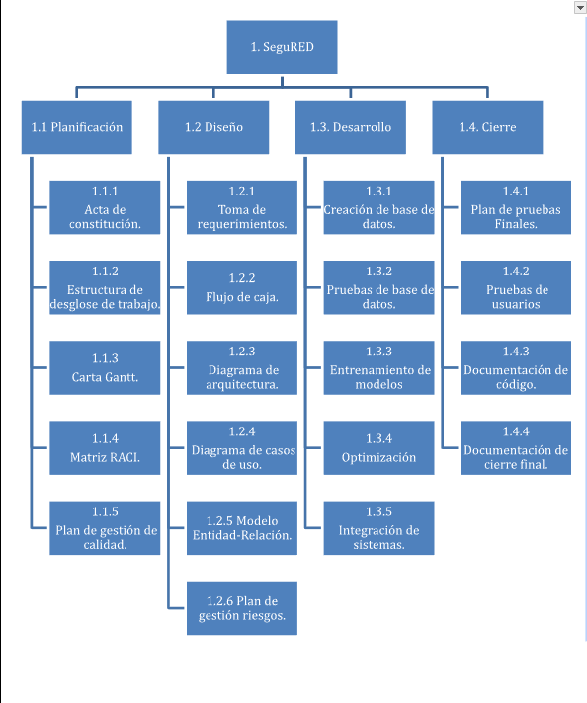

| **8. Carta Gantt** |
| --- |
| Busca un formato de Carta Gantt que te acomode y organiza en este las actividades planificadas en el punto anterior considerando el periodo asignado para el desarrollo de tu Proyecto APT. Debes mantener la temporalidad del periodo académico en el desarrollo de las tres fases que contempla la Asignatura de Portafolio de Título. |



